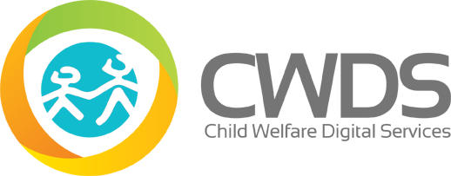

**CWDS**

**Service Desk ServiceNow & JIRA Working Instructions**

**Created by:**



**Project Name:** CWDS Service Desk ServiceNow & JIRA Working Instructions

**Document ID:**

**Version:** 1.0

**Issue Date:** TBD

Table of Contents

**SERVICENOW** 3

1 LOGON INSTRUCTION FOR SERVICENOW 3

2 MAIN PAGE OF SERVICENOW 3

3 INCIDENT LOGGING IN SERVICENOW 5

3.1 STEPS TO CREATE NEW INCIDENT AND MANDATORY FIELDS : 6

3.2 FIELDS AND SELECTIONS FOR CREATING NEW INCIDENT: 7

4 RESOLVING INCIDENT IN SERVICENOW 12

**JIRA** 16

1 CREATING A JIRA ISSUE 16

2 LINKING A JIRA ISSUE TO SERVICENOW INCIDENT 19

**CWDS Service Desk ServiceNow & JIRA Working Instructions**

# **SERVICENOW**

# LOGON INSTRUCTION FOR SERVICENOW

Link: <https://cwdsexpress.service-now.com>

Login ID : <OSI Email ID>

Password : <Local Password provided>

1. Login to ServiceNow with User ID and Password.

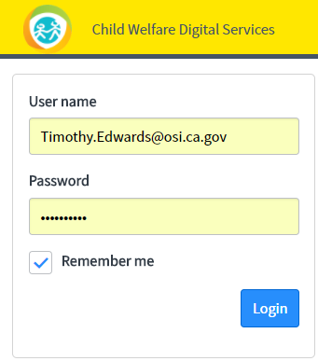

# MAIN PAGE OF SERVICENOW

1. Main Screen : Main Page of ServiceNow for CWDS :

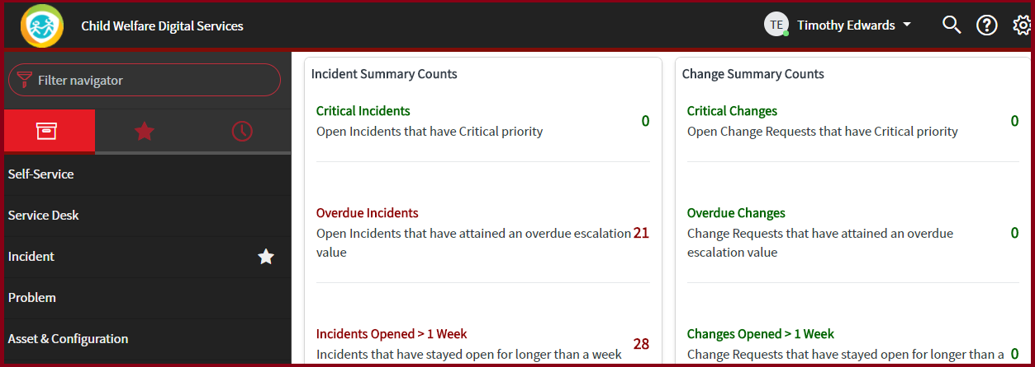

1. Navigator: At this time the only module an Analyst will go into is the “**Incident**”.

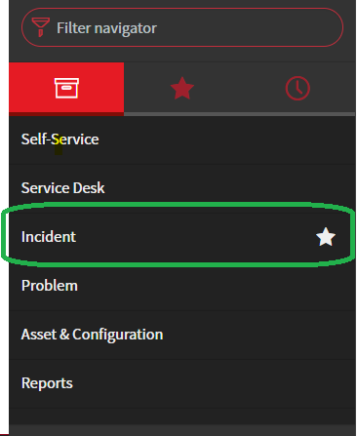

1. Shortcut in ServiceNow :
   1. The most efficient way to go into the Incident Module is to mark the Incident Management Module and all other sub categories as a **FAVORITE**. This can be done by clicking on the **STAR** icon on the right side of Incident.

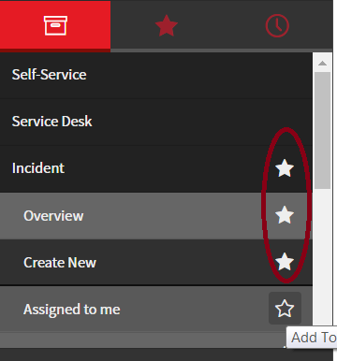

* 1. To access the modules and menus that have been marked as Favorite, click the STAR icon at the top menu.

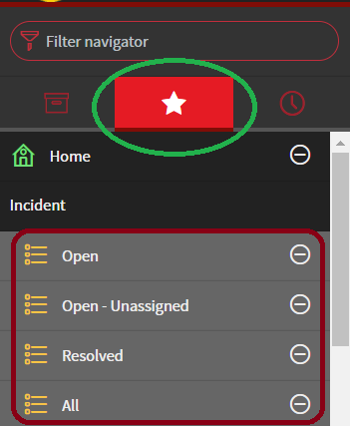

# INCIDENT LOGGING IN SERVICENOW

**Icons on Incident Creation page and their description**

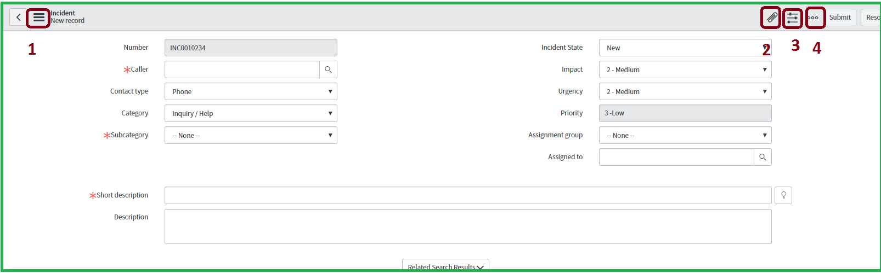

1. ** This icon, at the top left corner of Incident creation page, has a list of options.**

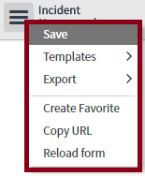

* + **Save:** Incidents can be saved using this option. Incidents can also be saved by clicking on “Submit”, for new Incidents, or “Update”, for existing Incidents, on the top or bottom of the Incident page.
  + **Template:** Templates can be created for repeated Incidents and used to save time in filling out the fields in the Incident page.
  + **Export:** The Incident page can be exported to a PDF using this option.
  + **Create Favorite:** This is an alternate way to set favorites and once this is clicked the module the Analyst is on will be added to his/her “Favorites” tab.
  + **Copy URL:** This option will copy the Incidents hyperlink which can be used to send via email or copy to other places.
  + **Reload Form:** This is to refresh or reload the page. On an existing Incident “Reload Form” will refresh the same Incident including the new changes made and on a New Incident, that was not saved yet, it will reload a new Incident with a new number.

1. ** : Emails or documents related to the Incident can be attached, to the Incident, by clicking on this icon, browse to the location of the file and attach it to the Incident. *Note:*** *Emails need to be saved first.*
2. **: This icon is used to customize or personalize the fields showing up on the Incident creation page. Note: *CWDS Service Desk will not update or modify these fields as all of these fields are necessary.***
3.  : This icon is used to access a Templates Toolbar. It has more options built-in including sending emails directly from the Incident to the User.**

***Note****: Rest of the fields and icons will be explained wherever necessary from Incident creation to Incident closure.*

## STEPS TO CREATE NEW INCIDENT AND MANDATORY FIELDS :

1. **Create a NEW Incident:** Click on the “Favorites” STAR and then “**Create New**” from the left Navigation Pane. You may also go to the Incident Module of the Main Page to create a New Incident.

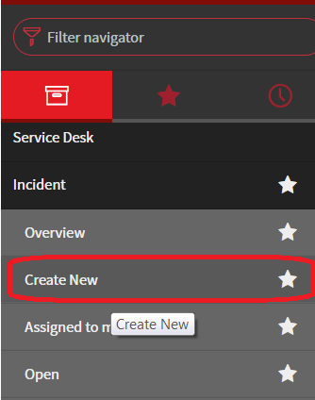 (OR)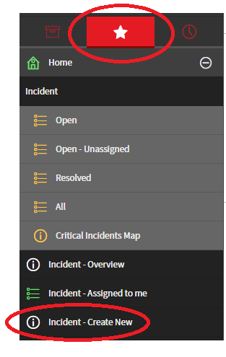

1. **Mandatory** fields for Incident Creation:

***Note:*** *These fields are identified with an* ***asterisk (*)***

* 1. Caller* :

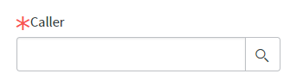

* 1. Category & Sub-Category * :

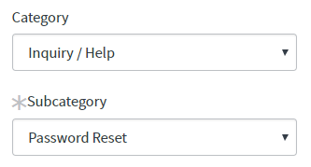

* 1. Short Description :

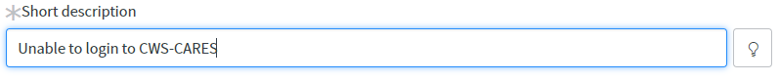

***Note****: Even though there are only a few* ***MANDATORY*** *fields, the Service Desk Analysts are strongly advised to fill out all the fields when creating Incidents as best practices.*

## FIELDS AND SELECTIONS FOR CREATING NEW INCIDENT:

1. **Number**: Once “**Create New**” is clicked, a new unique Incident Number is generated automatically.

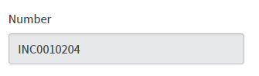

1. **CALLER:** The person contacting the Service Desk (by either phone, email, or walk-in) will be captured in this field.

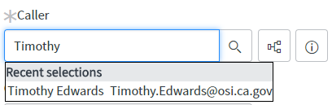

* 1.** 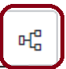: This icon comes up after a caller has been recognized and populated in the “Caller” field displays the Incident History for that Caller (All open, resolved & closed)**
  2. **: This icon comes up after a caller has been recognized and populated in the “Caller” field displays the detailed information of the Caller including the Contact email, Contact number, Title, Department, etc.**

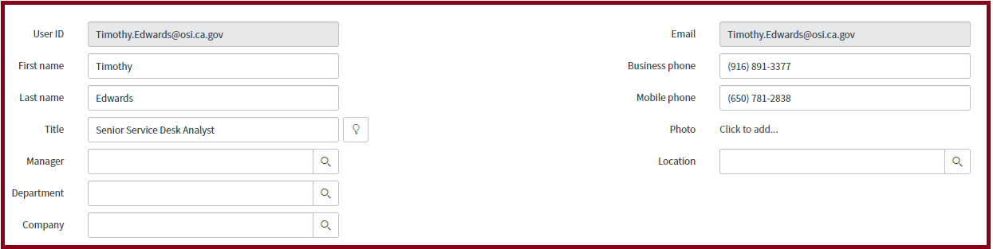

***Note:*** *If the person calling in is not in ServiceNow, click on “New” and update the person’s information and save the record. (Screen captures will be provided once this feature is enabled in ServiceNow).*

1. **Contact Type:** Select the appropriate Contact Type from the selection menu in the Incident. (Ex: Phone, Email, or Walk-in)

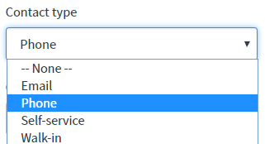

* 1. **Email:** Emails sent to CWDS Mailbox will either create a ServiceNow Incident automatically if the person is in ServiceNow, and if the person is not, in ServiceNow, the Incident will have to be **manually** created as a New Incident. In both of these scenarios the Contact Type will be defaulted or selected to “Email”.
  2. **Phone:** All Service Desk calls through the **Amazon Connect IVR** will be marked as “Phone” by the Analyst during the Incident creation.
  3. **Self-Service:** (Not enabled at this time so the Service Desk Analyst do not need to select this option)
  4. **Walk-in:** All Incidents reported in person at the Service Desk.

1. **Category:** Select the category that the issue reported belongs to. (Ex: Inquiry, Hardware, Software, Etc.)

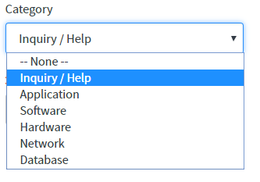

* 1. **Inquiry/Help – Sub-Categories (Password Reset, User Access, How To):** All password resets, “How To” questions, calls requesting Information on the application will be marked under “Inquiry/Help”.
  2. **Application – Sub-Categories (CARES, Legacy):** Bugs identified in the application and issues with the application reported either by user or by the Service Desk Analyst would be marked under “Application”.

**\*\*\*The above 2 selections are more likely to be used by CWDS Service Desk Analyst\*\*\***

* 1. **Software, Hardware, Network & Database:** As appropriate.

1. **Incident State:** By default the state will be “New” and unless the state is changed to a different state.

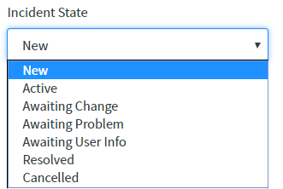

* 1. **New:** All new Incidents, created by Analysts or created by ServiceNow via emails, will default in “New” State.
  2. **Active:** Think of this state as “Work In Progress”. The Incident has been assigned to an Analyst and the state is changed to “Active” indicating that the individual has started research on the Incident.
  3. **Awaiting Change:** All Incidents that results in creating a **JIRA** issue should have their state changed to “Awaiting Change”. This will stop the clock that calculates the total time taken by Service Desk to resolve that Incident.
  4. **Awaiting Problem:** All Incidents that result in creating a Problem Ticket should have their state changed to “Awaiting Problem”. This will stop the clock that calculates the total time taken by Service Desk to resolve that Incident.

***Note:*** *Since Problem Management is not enabled during the initial go-live, Analysts will not be using this option until notified.*

* 1. **Awaiting User Info:** Incidents that require caller’s input or if the Analyst has requested more details from the caller; and is awaiting a response should have their state changed to “Awaiting User Info”. This will stop the clock that calculates the total time taken by Service Desk to resolve that Incident.
  2. **Resolved:** If the issue has been resolved the state must be changed to “Resolved”. If the User does not call back for the exact same issue within 3 days the state will automatically change to “Closed” by ServiceNow.
  3. **Cancelled:** This state will only be used once an update is received from the caller that the issue is no longer occurring. Also if the Caller found a solution to resolved the issue and advised the Analyst with the update.

1. **Impact:** Impact is a measure of business criticality caused by an Incident. For CWDS Service Desk the Impact is defined as Low, Medium & High.

***Note:*** *All Incidents are going to be defaulted to “MEDIUM” by the CWDS Service Desk*. *Subject to change in the future.*

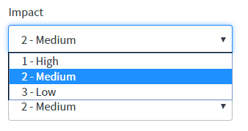

1. **Urgency:** Urgency provides a second measure of business criticality, which indicates the necessary speed of resolving an Incident of a certain impact. In CWDS Service Desk there are 3 levels of Urgencies: High, Medium and Low.

***Note:*** *All Incidents are going to be defaulted to “MEDIUM” by the CWDS Service Desk*. *Subject to change in the future.*

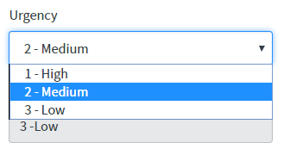

1. **Priority:** Priority is influenced by risk and resource availability; but is primarily determined by a combination of *impact* and *urgency*. In CWDS Service Desk there are 3 levels of Priorities: High, Medium and Low. Priority will auto-populate based on impact and urgency and will not change until Submitted.

***Note:*** *All Incidents are going to be defaulted to “MEDIUM” by the CWDS Service Desk*. *Subject to change in the future.*

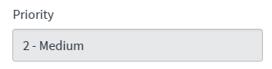

1. **Assignment Group:** Assignment Group is the group that the Incident is assigned to. All Incidents created by an Analyst in CWDS Service Desk or emails directed to CWDS Service Desk are defaulted to 3 Assignment Groups based on the time the Incident arrived.
   1. **Core -** Monday- Friday6 AM to 6 PM
   2. **Non-Core -** Monday- Friday 6 PM to 6 AM

Saturday, Sundays & State Holidays - 24 Hours

* 1. **CDSS –** TBD

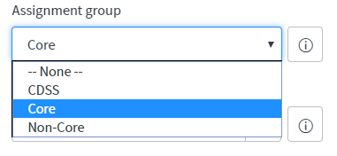

1. **Assigned to:** This is the Analyst the Incident is assigned to. If an Analyst creates an Incident and submits it, they will automatically becomes the “Assigned to”, by default, if the field is left blank. If the Incident is intended to be assigned to another Analyst, enter the Analyst’s Assignment Group and name.

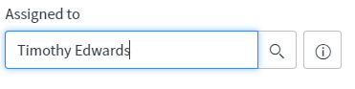

1. **Short Description:** This is the precise explanation of the actual issue. Succinct description needs to be placed here.

***Note****: Short Description will be a key while searching for Knowledge Articles and also for reporting purposes.*

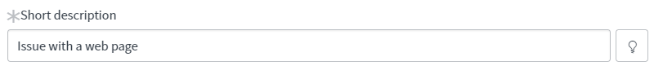

1. **Description:** This is also referred to as the **detailed description** where the complete story, reported by the caller is documented, and also as understood by the Analyst.

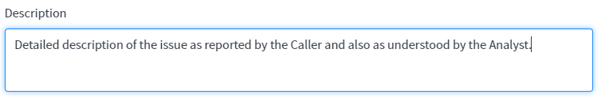

1. **Submit:** Click on Submit to have the Incident saved. This can be done at the top or bottom of the page. (See images below). Unless “Submit” is clicked the Incident is not valid and cannot be searched using the Incident Number.

**At the Top:**

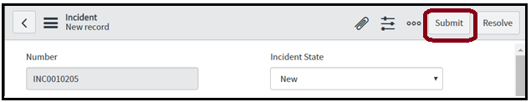

**At the Bottom:**

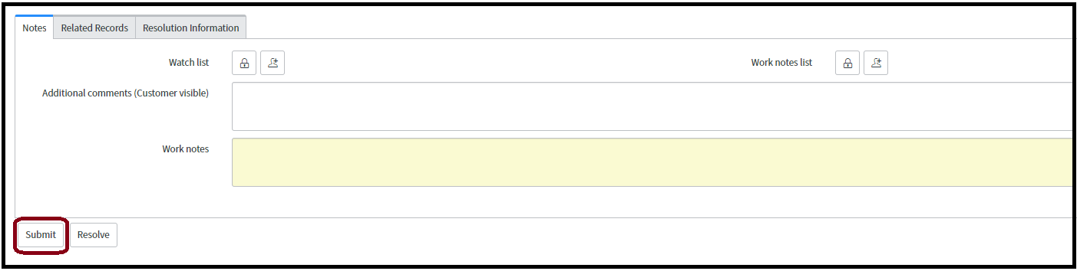

# RESOLVING INCIDENT IN SERVICENOW

1. **Resolution Information:** Once the Incident is Resolved click on the “Resolution Information” tab on the Incident

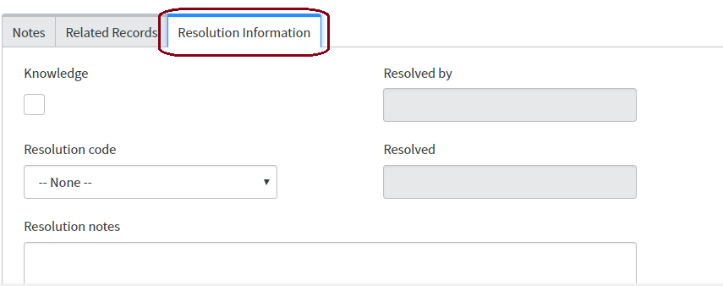

1. **Knowledge**: Check this box if a Knowledge Article does not exist for this issue and a solution has been identified by the Analyst.
2. Knowledge Article does not exist:

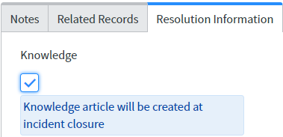

1. Knowledge Article exists and the Analyst has used it to resolve the Incident:

***Note****: Since no Knowledge Articles are enabled at this time screenshots will be added later.*

1. **Work Notes/Additional Comments (Customer Visible):** This field captures the work notes including the actions taken during the handling of the Incident. All Service Desk Analysts will have access to put in their notes in any open Incident even if the Incident is assigned to a different Analyst. It is to be noted that this field acts as 2 different fields. 1 . **Additional Comments (Customer Visible) and** 2. **Work Notes**
   * 1. **Additional Comments (Customer Visible) :** If the Checkbox is checked the label of this text box changes to “Additional Comments (Customer Visible) and then notes entered here will be sent to the User.

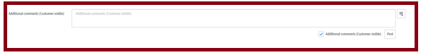

* + 1. **Work Notes**: If the Check box is unchecked then the notes entered here stays within the Incident for Service Analysts to view and this will not be sent to the User.

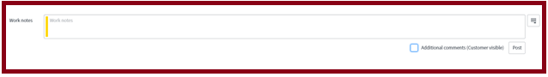

1. **Watch List and Work Notes** **List**: In the “Notes” tab there are 2 features available for Analysts to use to add people who want to or are required to know the progress/updates of the Incident. There is a difference between Watch List and Work Notes List which will be described below.
   1. **Watch List:**

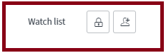

* + 1. The first icon (Lock Icon) has the option to add Users who will be able to see all updates added to the Incident in the “Additional Comments (Customer Visible)” section and this is used if a person has submitted the Incident on behalf on someone else or if the Supervisor of the User wants to know the updates of the Incident.
    2. The second icon is just to add yourself if the Analyst, who is working on the Incident, likes to follow the Incident he/she can click on this icon and ServiceNow adds the Analyst to the Watch List.
  1. **Work Notes List:**

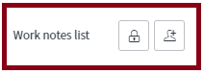

* + 1. The first icon (Lock Icon) has the option to add Users who will be able to see all updates added to the Incident in the “Work Notes List” section and this is used if an Analyst wants the Lead or Supervisor or other Analyst(s) to follow each and every update to this Incident.
    2. The second icon is just to add yourself if the Analyst, who is working on the Incident, likes to follow the Incident he/she can click on this icon and ServiceNow adds the Analyst to the Work Notes List.

1. **Related Records:** The only field that CWDS Service Desk Analyst will use during the initial rollout is the “Parent” field which will have the Parent Incident if the Analyst is working on a Child Incident and if there is a Parent Incident already created and being worked on.



1. **Resolution Code :** The CWDS Service Desk Team will use only 3 of the following codes during initial rollout:
   1. **Solved (Work Around)** – When Users are provided with a Work Around and not a permanent solution. Incidents, resolved by providing a Work Around or documenting and communicating a “Known Error”, will fall under “Solved (Work Around)” Resolution Code.

*Example for Known Errors*: **CWDS/CMS Legacy System**- Caller reports that the information they entered could not be saved and the child record is locked out. This is due to Optimistic Concurrency which is a Known Error.

* 1. **Solved (Permanently)** – All Incidents that were resolved by the Analyst with a permanent solution either in the initial call or after escalating to JIRA, and this resolution code would also include the Incidents reported for “How To” questions, Password Resets, etc. will fall under “Solved Permanently”.
  2. **Resolved by Caller** – This Resolution Code is selected only when the Incident is either cancelled by User or later confirmed by caller that the issue is resolved by Caller themselves.

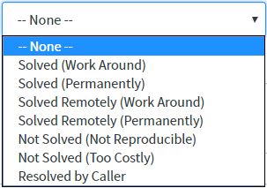

1. **Resolution Notes:** Detailed notes on the steps taken to resolve the Incident is captured in “Resolution Notes”.

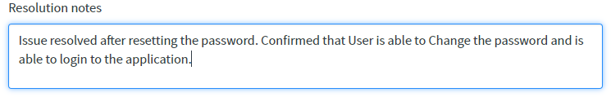

1. **Resolve:** Click on “RESOLVE” after completing Step 1 to 5 to resolve an Incident and move it to “Resolved” State.An Incident can also be resolved by manually changing the state to “Resolved” and clicking on “Update” at the bottom of the Incident.

**Option 1:**

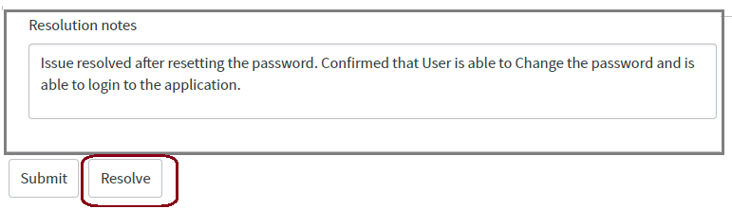

**(OR)**

**Option 2:**

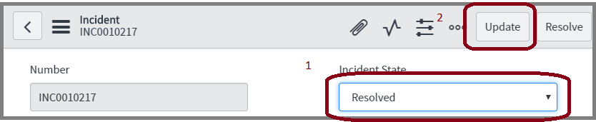

# **JIRA**

# CREATING A JIRA ISSUE

1. **Login :** Login to JIRA with the below link:

[**https://osi-cwds.atlassian.net/secure/Dashboard.jspa**](https://osi-cwds.atlassian.net/secure/Dashboard.jspa)

1. **User ID and Password:** Enter the User ID and Password provided.

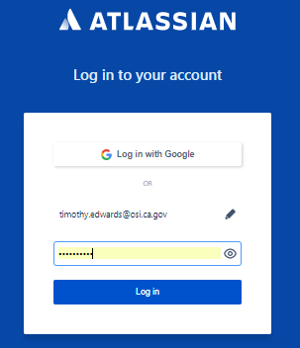

1. **Create:** Click on Create to create a new Story/Issue on the Service Desk Board for Level 3 Support which includes Code Changes, Functionality Changes, bug fixes or Enhancements using a JIRA Issue.

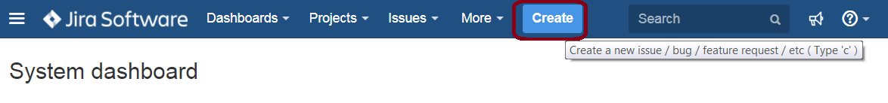

1. **Project:** Select the “Test ServiceNow” Board from the list of boards available. CWDS Service Desk will write all JIRA issues to the Board labeled **ServiceDesk**.

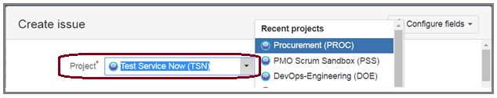

1. **Issue Type:** Issue Type for CWDS Service Desk is always “Story” and the same has to be picked from the dropdown available.

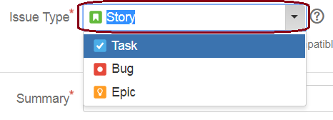

1. **Summary:** This is the “Short Description” from the ServiceNow Incident. This should be copied and pasted from the ServiceNow Incident.

***Note:*** *Always copy the ServiceNow Incident Number to the front of the Summary as this is used to relate to the ServiceNow Incident.*

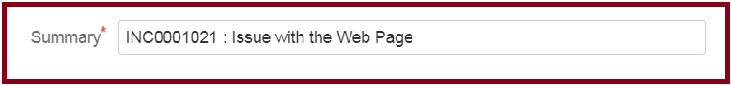

1. **Description:** This is the “Description” from the ServiceNow Incident. This can be copied and pasted from the ServiceNow Incident.

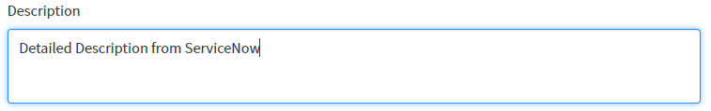

1. **Priority:** Priority for all CWDS JIRA issues would be by default “Medium” and they have to be kept at the same Priority level.

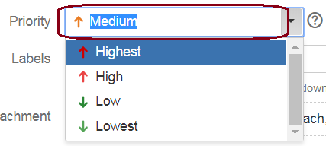

1. **Labels:** The only label that will be entered for all CWDS Service Desk reported Issues would be “ServiceDesk”. The exact name has to go in with the exact same upper and lower case letters and no space.



1. **Create:** Click on Create to have the issue created/saved on the **ServiceDesk** Board for Developers to go in and pull the issue into their respective boards.

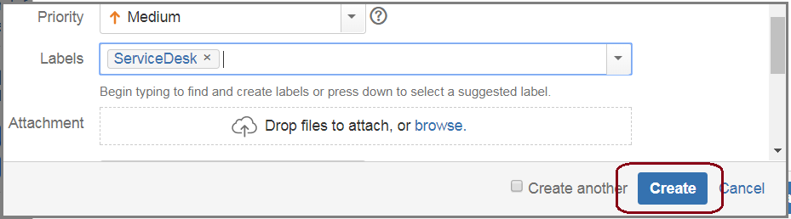

# LINKING A JIRA ISSUE TO SERVICENOW INCIDENT

1. Once the issue is created, click on Issues -> Reported By Me

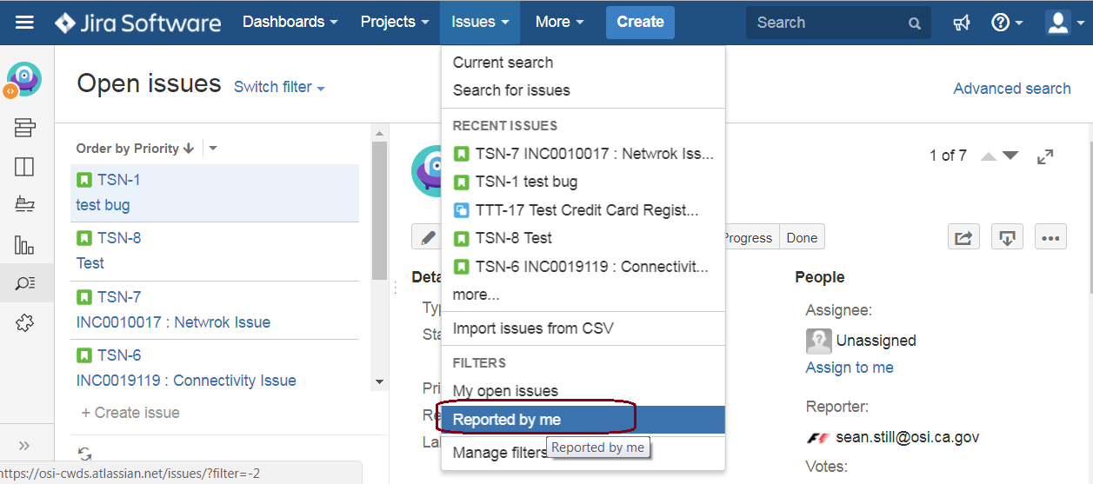

1. Look for the JIRA Issue that was created and right click, on the issue number, and select “**Copy link address**”.

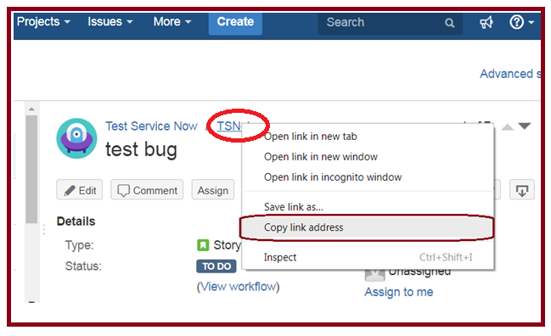

1. Open the ServiceNow Incident and go to “Work Notes” and add the JIRA Hyperlink and click “Update”

***Note****: No matter how many boards the issue gets moved to the hyperlink will remain the same.*

